Panneerselvam N
(27/07/2021)

Today i had trained pp yolo model upto 1797 epochs with kaggle. The minimum loss is 19. And also created Test dataset for evalvation.

Evaluating Result : (Training Data)
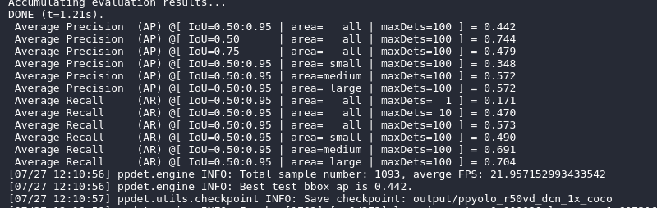
Due to network issue not able to evaluate with images , so I will do it tomorrow.

Test Data link : https://drive.google.com/file/d/1csGX31FDPXQMq1OLhZNhEo68DmPV7e3L/view?usp=sharing

Json link :
https://drive.google.com/file/d/1hYdCeBD8syidQtHEQLUJua2CW91eRht4/view?usp=sharing

Code for downloading test data :
https://github.com/Panneer003/Aero2astro_code/blob/main/PP_Yolo_with_official/Coco_download_test_data.ipynb

